PROGRESS REPORT FOR B.TECH. CSE FINAL YEAR MAJOR PROJECT

“SynthiVerse AI: Diffusion and GAN-powered Creative Synthesis System”



To be presented at

GRAPHIC ERA HILL UNIVERSITY,

BHIMTAL

by

Name: Harshit Waldia Name: Shivam Sah Project Guide: Prof. Dr. Ankur Singh Bist

Univ Roll: 2161170 Univ Roll: 2161311 Designation: HOD & Associate Professor

Section: D Section: D Department: Computer Science and Engg.

|  |
| --- |
| Name of Supervisor: Mr. Ayush Kapri |
| Designation: Project Associate |
| Name of Institution: Graphic Era Hill University |
| Signature: |

**Introduction**

**SynthiVerse.AI: Diffusion and GAN-powered Creative Synthesis System** is built on a foundation of advanced **generative AI techniques**, combining **Diffusion Models** and **Generative Adversarial Networks (GANs)** to enable high-quality text-to-image, text-to-audio, and text-to-video synthesis. The system is designed to provide **contextually accurate, semantically rich, and aesthetically refined outputs**, making it a versatile tool for creative applications.

**Core Technologies and Architecture**

1. **Diffusion Models**
   * SynthiVerse.AI employs **denoising diffusion probabilistic models (DDPMs)** to progressively refine outputs from noise, ensuring fine-grained detail in generated content.
   * **Latent Diffusion Models (LDMs)** reduce computational requirements by working in a compressed latent space rather than pixel space, enhancing efficiency without sacrificing quality.
   * Utilizes preconditioning and classifier-free guidance for improved text-image alignment and stylistic consistency.
2. **Generative Adversarial Networks (GANs)**
   * GANs complement diffusion models by refining textures and enhancing high-frequency details in generated media.
   * **StyleGAN3 and BigGAN** architectures are leveraged for high-resolution image synthesis, improving sharpness and structure.
   * Audio generation benefits from adversarial training to produce realistic speech, music, and ambient sounds.
3. **Text-to-Image, Text-to-Audio, and Text-to-Video Generation**
   * **CLIP (Contrastive Language-Image Pretraining)** is used to map textual descriptions to visual representations, ensuring meaningful alignment.
   * **Audio generation models**, such as **WaveNet and DiffWave**, synthesize realistic speech and soundscapes from textual inputs.
   * **Video synthesis** utilizes **transformer-based diffusion models** like **Imagen Video** or **Make-A-Video**, generating high-quality, consistent motion sequences.
4. **Model Training and Optimization**
   * Trained on **multi-modal datasets** combining **text, images, and videos** from diverse sources.
   * Implements **LoRA (Low-Rank Adaptation)** fine-tuning to allow adaptation to specific user needs without requiring full retraining.
   * Uses **vector quantization** for efficient latent space representation, improving scalability.
5. **Computational Framework and Deployment**
   * Built with **PyTorch and TensorFlow**, leveraging **Hugging Face Transformers** and **Diffusers library** for model training and fine-tuning.
   * Accelerated inference with **TensorRT and ONNX** for optimized deep learning model execution.
   * **Distributed training with TPU/GPU clusters**, utilizing frameworks like **Ray Tune** for hyperparameter optimization.
   * Available as an **API-based service**, allowing seamless integration into creative workflows and enterprise applications.

**Key Features and Capabilities**

* **Customizable Outputs:** Users can control artistic style, realism, and structural coherence via adjustable parameters.
* **Multi-Stage Refinement:** A hybrid pipeline of diffusion and GAN models enhances quality while maintaining efficiency.
* **Semantic Understanding:** Leverages large-scale language models for contextual grounding in generated media.
* **Real-Time Generation:** Optimized inference for fast synthesis, supporting real-time preview and interactive refinements.

**Future Enhancements**

* **Integration of 3D Generative Models** for text-to-3D object and scene synthesis.
* **Enhanced Video Temporal Consistency** using frame interpolation and motion-aware diffusion.
* **Interactive Fine-Tuning** for users to guide outputs through iterative refinement.

By merging the best of diffusion, GANs, and transformer-based architectures, **SynthiVerse.AI** delivers a state-of-the-art generative experience, enabling seamless creative synthesis across multiple modalities.

**Abstract: -**

SynthiVerse.AI is an advanced generative AI system that leverages Diffusion Models and Generative Adversarial Networks (GANs) to create high-quality multimedia content from textual descriptions. By integrating text-to-image, text-to-audio, and text-to-video synthesis, the platform provides a seamless and efficient solution for content creators across various domains.

This project explores state-of-the-art deep learning architectures, including Denoising Diffusion Probabilistic Models (DDPMs), Latent Diffusion Models (LDMs), StyleGAN3, BigGAN, CLIP, and transformer-based video synthesis models, to generate semantically rich and contextually accurate outputs. The system is trained on diverse multi-modal datasets and optimized using LoRA fine-tuning, vector quantization, and distributed TPU/GPU acceleration to enhance efficiency and adaptability.

Our analysis evaluates model performance across multiple metrics, emphasizing realism, coherence, and computational efficiency. The findings highlight SynthiVerse.AI's potential to revolutionize creative industries, offering scalable, high-fidelity generative capabilities for entertainment, education, design, and research applications.

**Methodology: -**

* The **SynthiVerse.AI** project follows a structured approach to building an advanced generative AI system for **text-to-image, text-to-audio, and text-to-video** synthesis using **Diffusion Models** and **GANs**. The methodology involves data collection, model training, evaluation, and optimization to ensure high-quality and contextually accurate multimedia generation.
* **1. Data Collection & Understanding**
* Gather **multi-modal datasets** containing **text-image, text-audio, and text-video pairs** from diverse sources.
* Perform **exploratory data analysis (EDA)** to understand data distribution, quality, and alignment between modalities.
* Use **pre-trained embeddings (CLIP, T5, Whisper, Wav2Vec)** for initial data encoding and semantic understanding.
* **2. Data Preprocessing**
* **Text Processing:** Tokenize textual inputs and map them to multimodal representations using **transformer-based encoders (T5, BERT, CLIP)**.
* **Image Preprocessing:** Normalize and resize images to **512×512** for diffusion model training.
* **Audio Preprocessing:** Convert raw waveforms into **mel spectrograms** for generative models like **WaveNet and DiffWave**.
* **Video Preprocessing:** Extract **keyframes and motion vectors** to improve consistency in generated sequences.
* **Feature Engineering:**
* Encode text prompts using **CLIP embeddings** for cross-modal alignment.
* Apply **vector quantization (VQ-VAE-2, VQGAN)** for compact latent space representation.
* Use **spectrogram augmentation** for robust text-to-audio generation.
* **3. Model Selection & Training**
* Train and compare multiple deep learning models:
* **(a) Text-to-Image:**
* **Latent Diffusion Models (LDMs)** for efficient, high-quality synthesis.
* **StyleGAN3 and BigGAN** for texture refinement and realism.
* **Cross-attention mechanisms** to enhance text-image coherence.
* **(b) Text-to-Audio:**
* **WaveNet and DiffWave** for natural-sounding speech and sound generation.
* **MelGAN and HiFi-GAN** for high-fidelity audio synthesis.
* **(c) Text-to-Video:**
* **Video diffusion models (Imagen Video, Make-A-Video)** for frame interpolation and temporal consistency.
* **3D U-Net architectures** for video reconstruction.
* Utilize **multi-GPU and TPU acceleration** for parallelized training.
* Implement **LoRA (Low-Rank Adaptation)** fine-tuning for efficient domain-specific customization.
* **4. Model Evaluation**
* Evaluate generated outputs based on:
* **FID (Fréchet Inception Distance)** for image quality assessment.
* **Inception Score (IS)** for image realism.
* **Mel Cepstral Distortion (MCD)** for speech synthesis quality.
* **Structural Similarity Index (SSIM)** for video quality.
* Compare models across multiple **realism, coherence, and computational efficiency** metrics.
* **5. Optimization & Refinement**
* Implement **classifier-free guidance** to improve text-image alignment.
* Use **adaptive noise scheduling** for faster and more stable diffusion model convergence.
* Experiment with **latent space interpolation** for smoother transitions in video generation.
* Fine-tune **prompt conditioning** to enhance user control over generated content.
* **6. Deployment & API Integration**
* Convert models into optimized **ONNX/TensorRT formats** for real-time inference.
* Deploy as an **API service** using Flask/FastAPI for integration with creative platforms.
* Implement **server-side caching and parallel inference pipelines** to improve response time.
* **7. Result Visualization & Reporting**
* Generate side-by-side comparisons of different model outputs.
* Plot **loss curves, FID scores, and feature embeddings** for analysis.
* Document findings and **future research directions** for continuous improvement.

RESULTS:-

A count plot was created to visualize the number of cars registered at various intersections and assess traffic distribution over time.

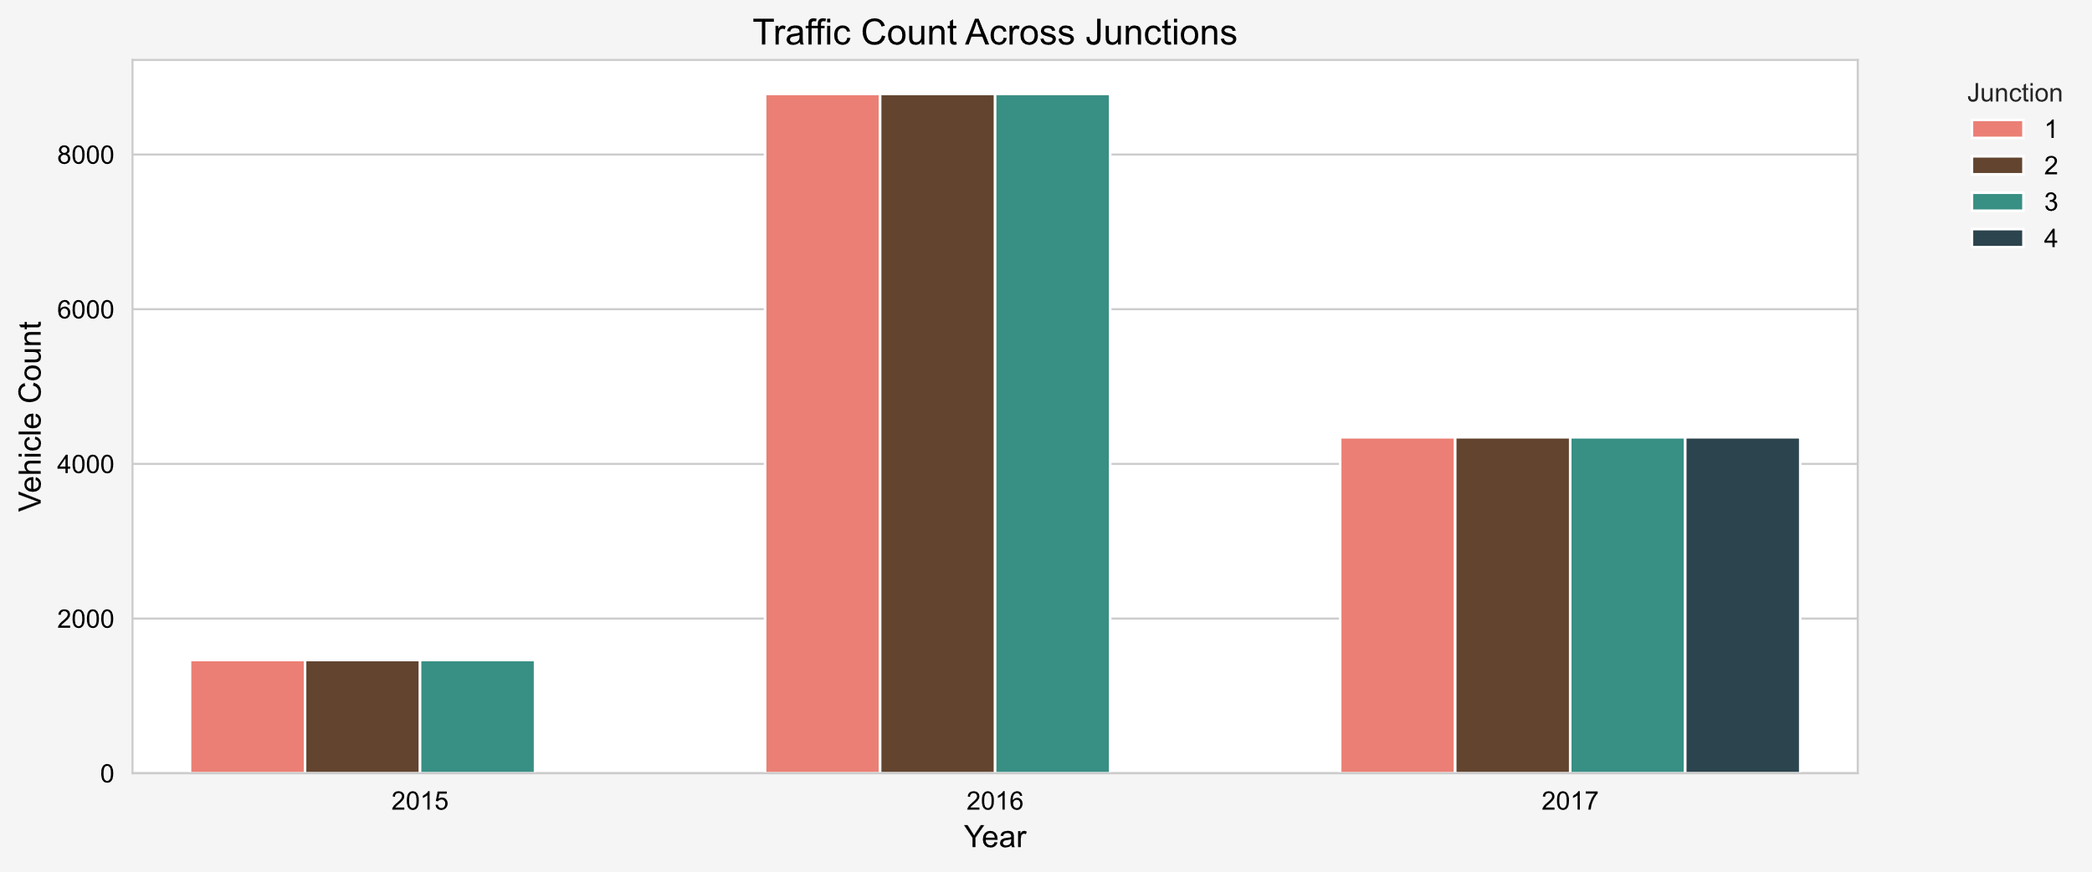

Fig1. Traffic Count Across Junctions

This part evaluates the performance of the Logistic Regression for predicting high and low traffic conditions.

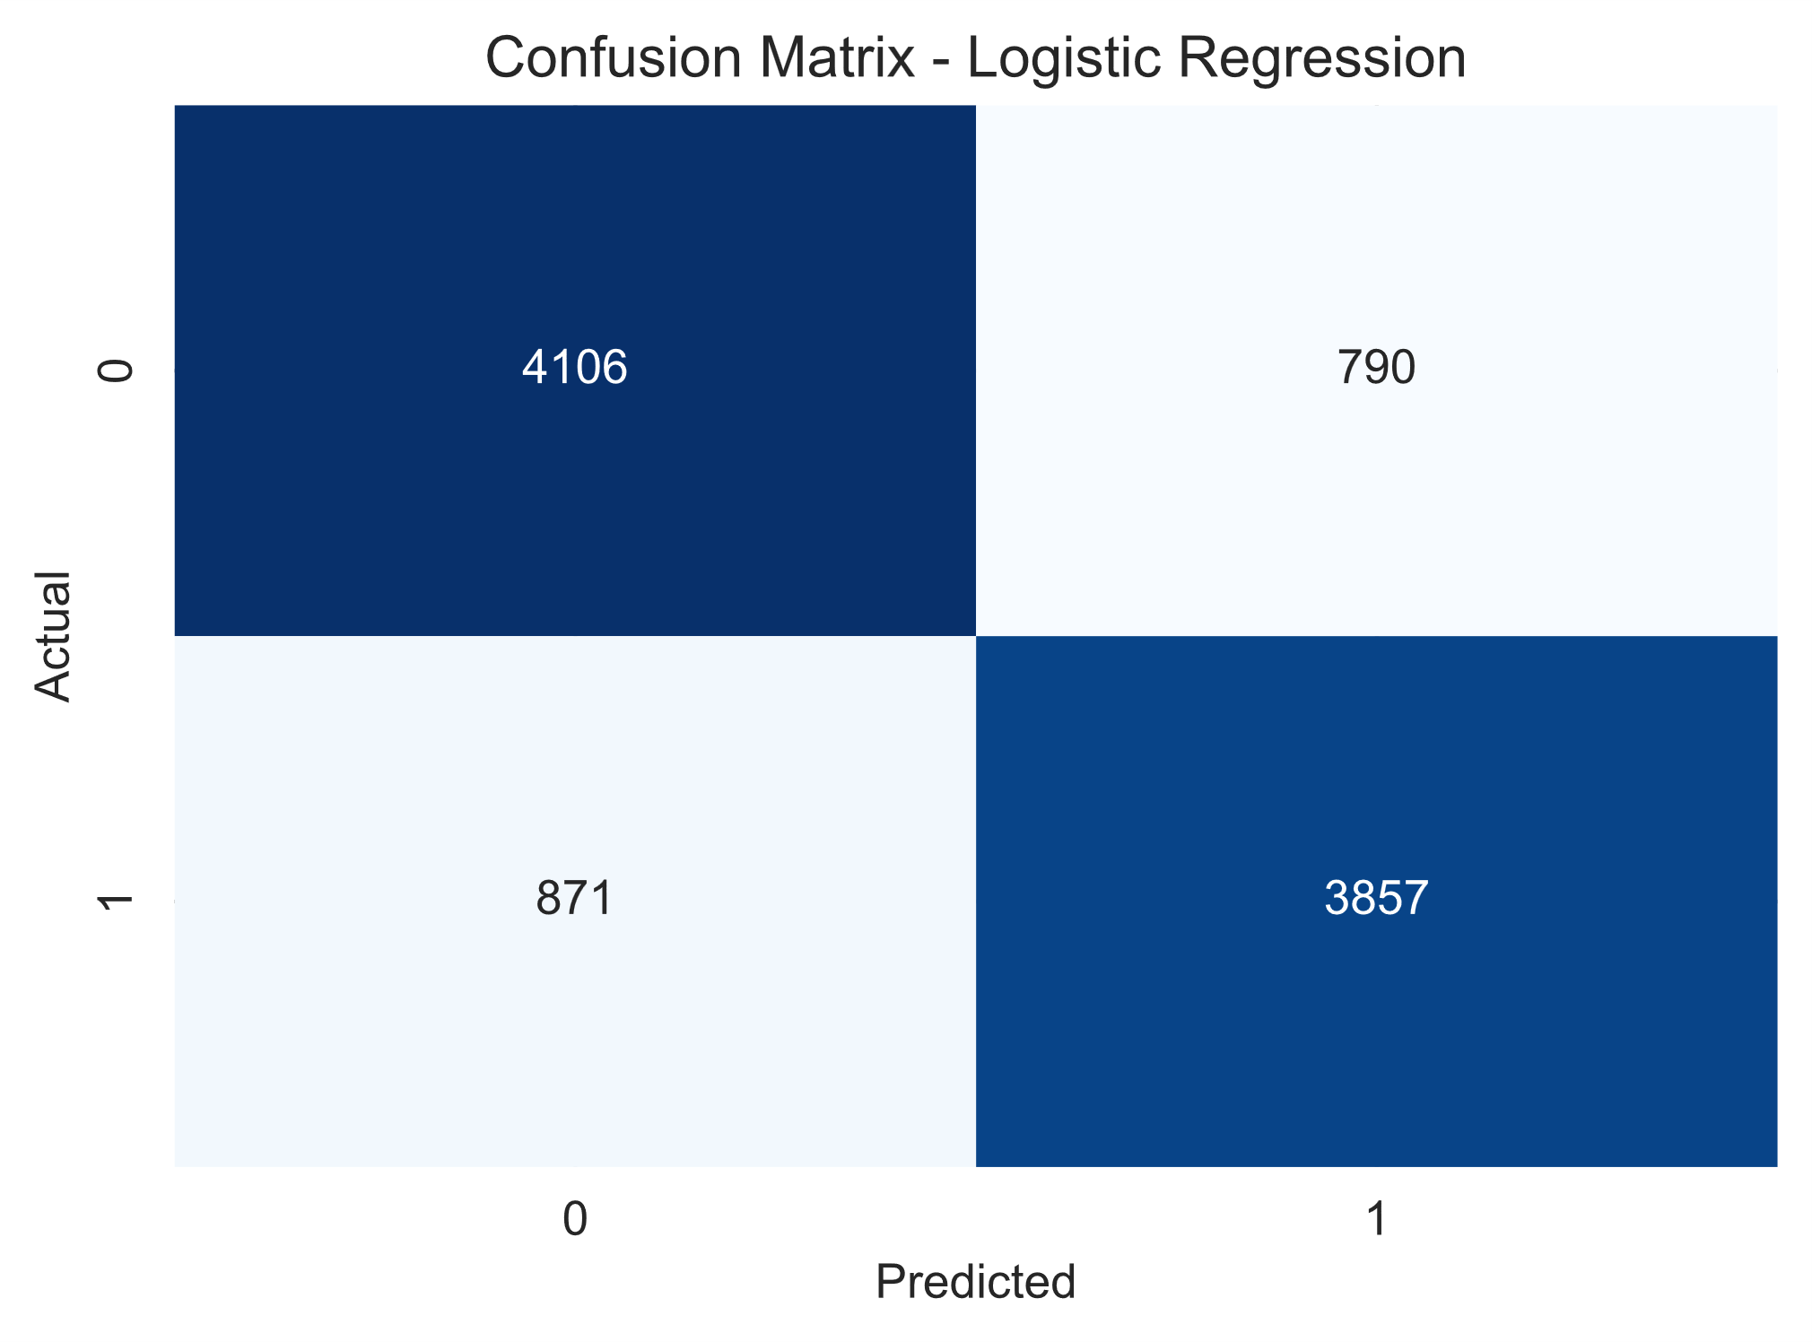

Fig 2. Confusion matrix of logistic regression.

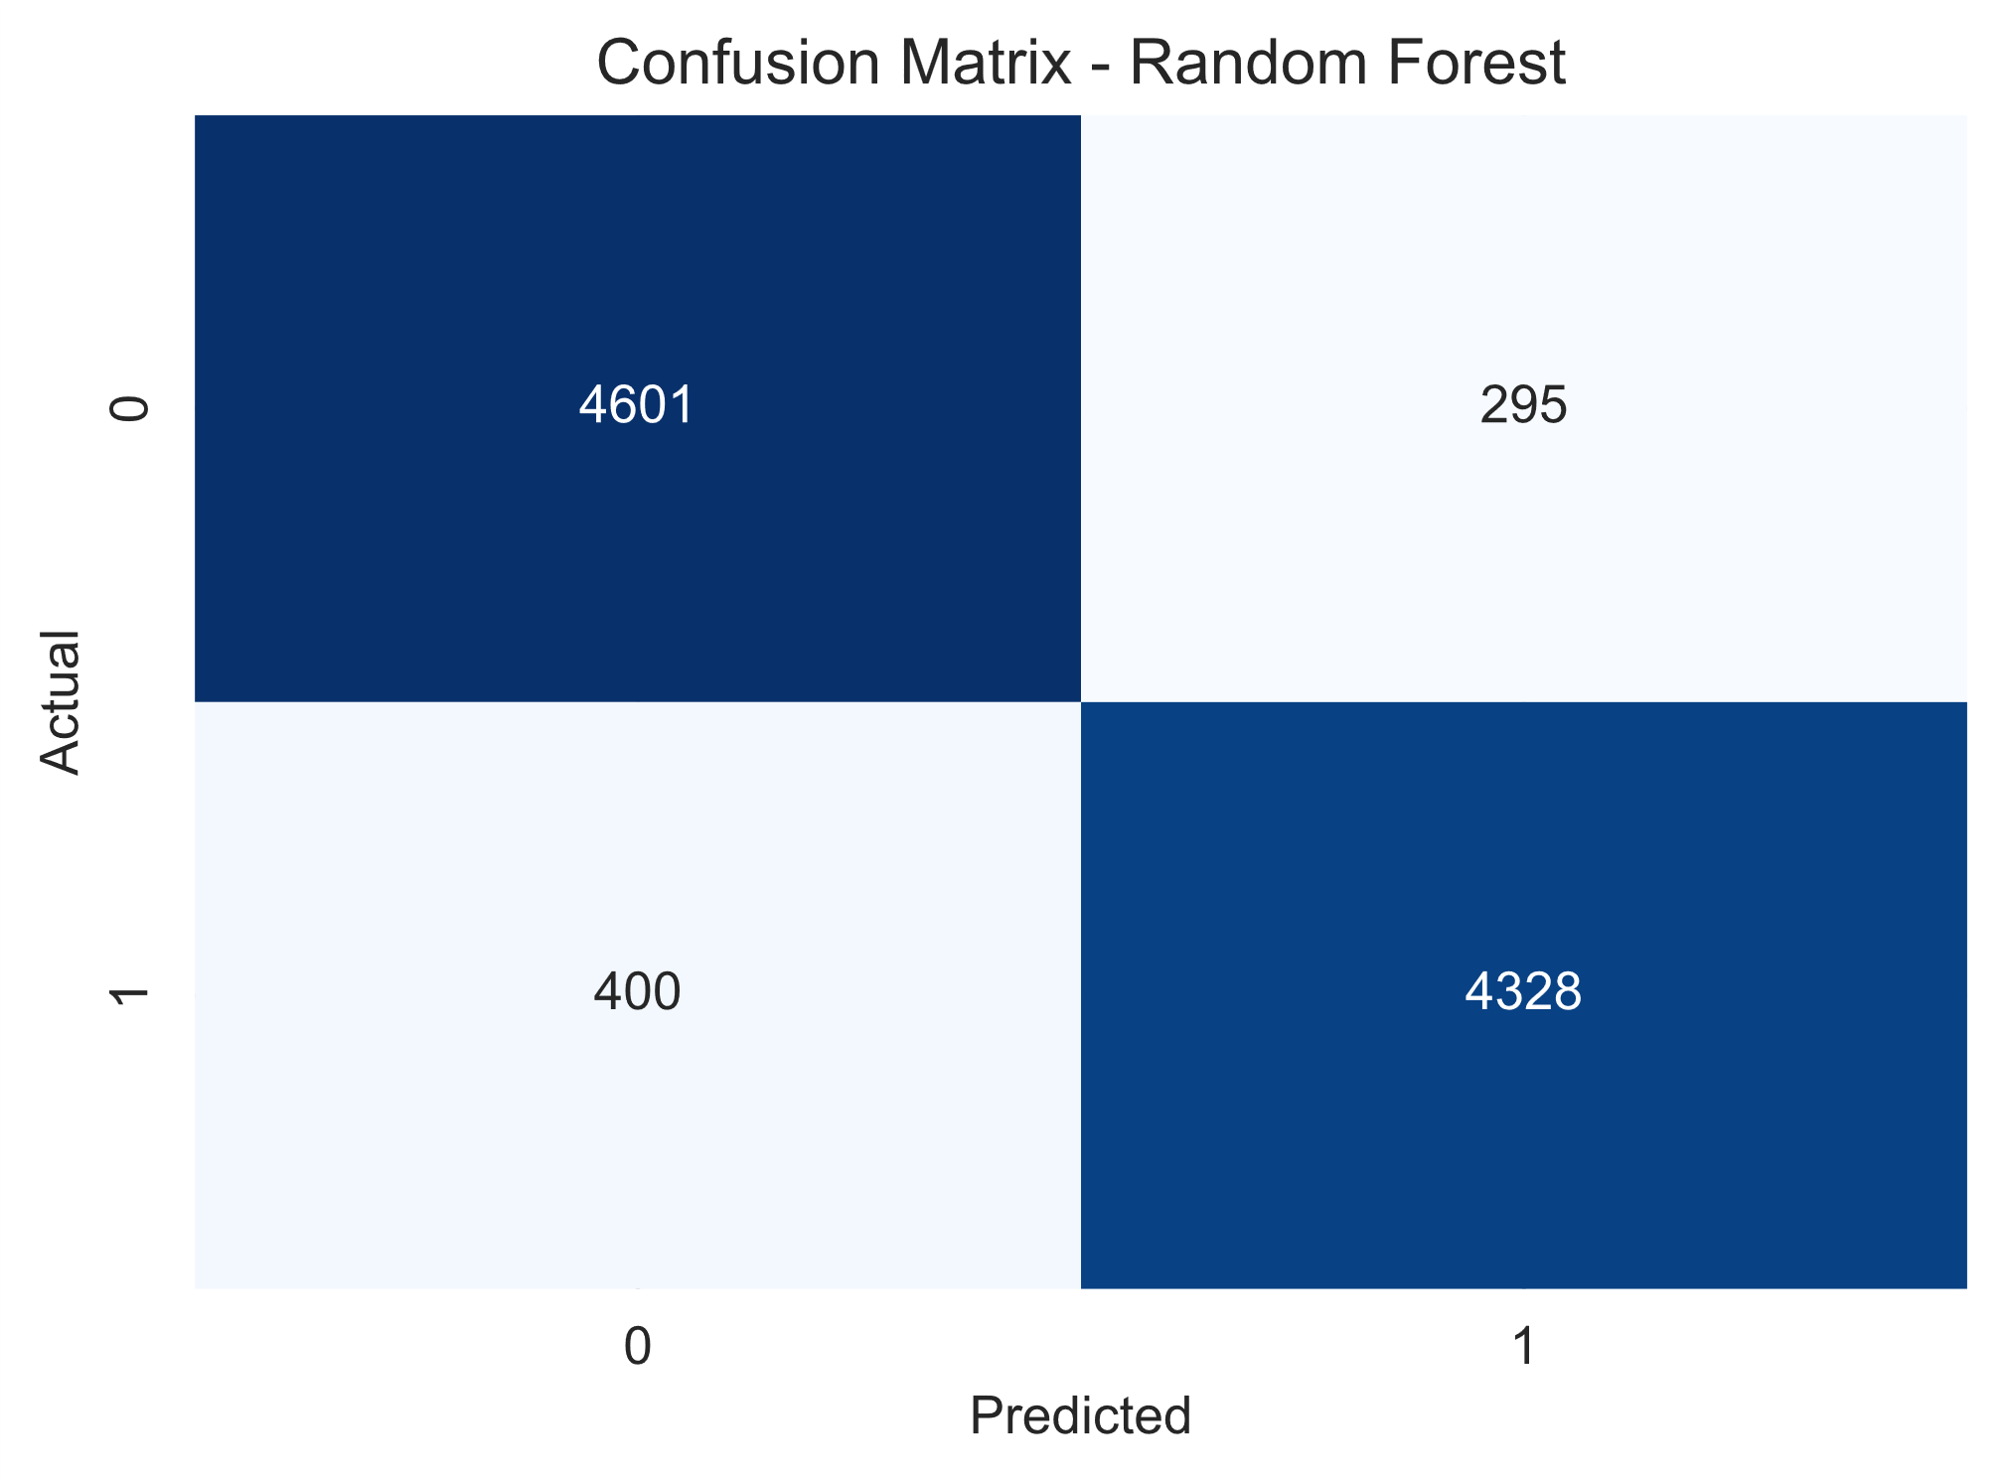

Fig 3. Confusion matrix of Random Forest classifier

|  |  |  |  |  |
| --- | --- | --- | --- | --- |
| Class | Precision | Recall | F1-Score | Support |
| Low Traffic(0) | 82% | 84% | 83% | 4,896 |
| High Traffic(1) | 83% | 82% | 82% | 4,728 |
| Macro Avg. | 83% | 83% | 83% | 9,624 |
| Weighted Avg. | 83% | 83% | 83% | 9,624 |

Fig 4. Tabular Representation of Evaluation Metrics

The model achieved an overall accuracy of 82.74% which indicates strong performance in distinguishing high and low traffic conditions.

To evaluate the effectiveness of the Logistic Regression model, another model is trained using the Random Forest classifier.

|  |  |  |  |  |
| --- | --- | --- | --- | --- |
| Class | Precision | Recall | F1-Score | Support |
| Low Traffic(0) | 92% | 94% | 93% | 4,896 |
| High Traffic(1) | 94% | 92% | 93% | 4,728 |
| Macro Avg. | 93% | 93% | 93% | 9,624 |
| Weighted Avg. | 93% | 93% | 93% | 9,624 |

Fig 5. Tabular Representation of Evaluation Metrics

The random forest model achieved an overall accuracy of 92.78% which indicates random forest model is more effective model for traffic prediction.

The Logistic Regression model is still useful due to its simplicity and interpretability, but it may not be as effective for complex traffic patterns.